- St. Andrew Parish  October 2025 | October:  Month of the Rosary  “To recite the rosary is nothing other than to contemplate with Mary the face of Christ.” St. John Paul II
Our Lady of Fatima   | “Pray the rosary every day to obtain peace for the world.”  As a Parish Family, Let’s Pray a Living Rosary: The Glorious Mysteries INVITATION#1 WHERE? Church Lawn HOW? Reciting 1 decade after each mass below. WHEN? See Schedule. Saturdays after 4pm mass. Sundays after 11am mass  10/4&5- The First Glorious Mystery: The Resurrection  10/11&12 The Second Glorious Mystery: The Ascension  10/18&19 The Third Glorious Mystery: The Descent of the Holy Spirit  10/25&26-The Fourth Glorious Mystery: The Assumption &  The Fifth Glorious Mystery: The Coronation  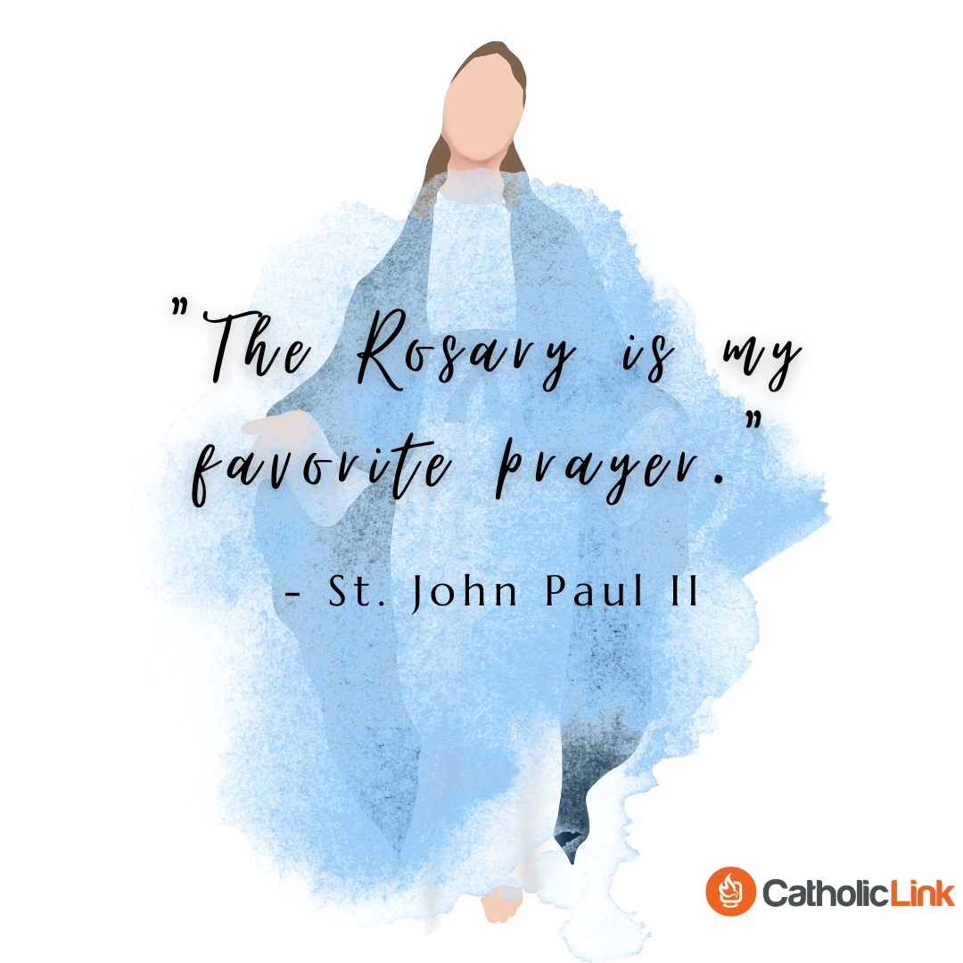  Sponsored by St. Andrew the Apostle Legion of Mary  INVITATION #2: October Pledge- Use the QR code to learn how!

