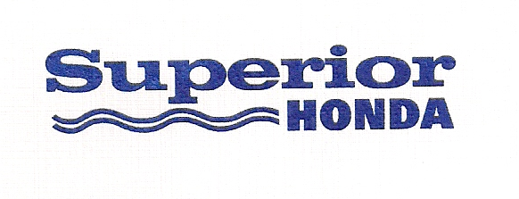
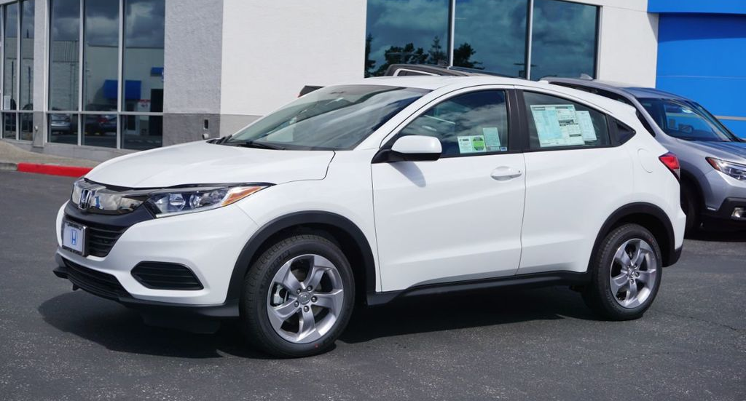

2020 Honda HR-V LX
Value: $21,765
$25 each or 6 for $100
Drawing: Friday, October 30, 2020, at 8:30AM
Winner Need Not Be Present

